JPO 152 Assignment 2
Kinematics
Due date: 8th March 2013
Surname:
Student No:
Field Of Study:
Group:
Total | /20

I am aware of the University of Pretoria’s plagiarism clause and steps that may be taken against me, should I be found guilty. This work is my original effort.

Signature: __________________
Question 1 [6]
Consider the following graph of velocity as a function of time for a drunk driver trying to drive along a straight road.
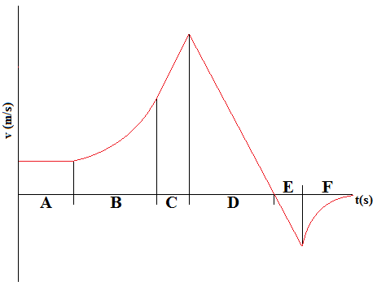
- During what portions of the drivers motion do the equations of motion apply. List the lettered intervals and explain your answer (3)
A,C,D,E. Equations of motion only apply when the acceleration experienced is a constant value. The gradient of a velocity vs time graph is the acceleration of an object. During this stage the gradient of the graph is a constant value.
- At the end of which time interval is the driver at the furthest distance from his starting point? Explain (3)
D. The displacement is given by the integral of a velocity vs time which is the area under the curve. The point where there is the maximum area under the curve will thus represent the point when the driver is at the maximum distance from his original starting point
Question 2 [11]
A velociraptor spots you 90 meters away and attacks, accelerating at $6 m∙s^{-2}$ up to its top speed of $25 m∙s^{-1}$. When it spots you, you begin to flee, instantaneously reaching your top speed of $9 m∙s^{-1}$.Your goal is to get to a tree in the distance and climb up it to safety.
- How long will it take for the velociraptor to catch you? (5)
For Portion where velociraptor is accelerating:
For the velociraptor: $v=v_{0}+at⇒t=\frac{v-v_{0}}{a}=\frac{25}{6}=4.2s$
And $x=v_{0}t+\frac{1}{2}at^{2}=\frac{1}{2}\left(6\right){\left(\frac{25}{6}\right)}^{2}=\frac{625}{12}m$
For you: $x=vt+90=9\left(\frac{25}{6}\right)+90=\frac{255}{2}m$
Thus you are $∆x=\frac{905}{12}m$ ahead of the velocirator when it reaches its maximum speed
After the velociraptor is moving at maximum speed:
Let $x_{2}$ be the point where you are caught
$For the velociraptor:$ $x_{2}=vt=25t$
For you: $x_{2}=vt+∆x=9t+\frac{905}{12}$
Solving these two equations simultaneously:
$$25t=9t+\frac{905}{12}⇒16t=\frac{905}{12}⇒t=\frac{905}{192}=4.7s$$
Hence total time taken to catch you is: 8.9s
- What distance do you cover in this time? (2)
$$x=vt=9\left(8.9\right)=80.1m$$
- What is the maximum distance the tree can be from your starting point if it takes you two seconds to climb to safety? (4)
Let $x_{3}$ be the position of the tree. Since it takes you two seconds to climb to safety then
For velociraptor: $x_{3}=vt=25t$
For you: $x_{3}=v\left(t-2\right)+∆x=9t-18+\frac{905}{12}=9t-\frac{689}{12}$
Solving simultaneously again one gets:
$$25t=9t+\frac{689}{12}⇒t=\frac{689}{192}=3.56s$$
Hence total time is 7.78s
And distance you need to run must be: $x=vt=9\left(7.78\right)=70m$

Question 3 [3]
Explain briefly why two balls with different initial horizontal velocities but the same initial vertical velocities when released from the same height above the ground will strike the ground at the same time (you may ignore the effects of air resistance).
Motion in the y-direction is completely independent of motion in the x-direction. Since the two balls are projectiles and have the exact same initial velocity in the y direction, vertical acceleration, and vertical displacement are the same then by
$$∆y=v_{0,y}t-\frac{1}{2}gt^{2}$$
Then the time to fall and strike the ground will be exactly the same

